Machine Learning techniques for detecting GPS Spoofing Attacks in Mission Critical Military IoT Devices
A major project report submitted in partial fulfilment of the requirement for the award of degree of
Bachelor of Technology
in
Computer Science & Engineering

Submitted by
Rashi Sharma (221030262)
Anmol Sharma (221030285)
Akanksha Sharma (221031017)
Simran Suri (221030243)
Under the guidance & supervision of
Dr. Pradeep Kumar Gupta
Department of Computer Science & Engineering and
Information Technology
Jaypee University of Information Technology, Waknaghat, Solan - 173234 (India)
December 2025

DECLARATION
We hereby declare that the work presented in this report entitled ‘Machine Learning Techniques for detecting GPS Spoofing Attacks in Mission Critical Military IoT Devices’ in partial fulfillment of the requirements for the award of the degree of Bachelor of Technology in Computer Science & Engineering / Information Technology submitted in the Department of Computer Science & Engineering and Information Technology, Jaypee University of Information Technology, Waknaghat is an authentic record of my own work carried out over a period from August 2023 to May 2024 under the supervision of Dr. Pradeep Kumar Gupta (Assistant Professor, Department of Computer Science & Engineering and Information Technology).

The matter embodied in the report has not been submitted for the award of any other degree or diploma.

Rashi Sharma Anmol Sharma
221030262 221030285

Akanksha Sharma Simran Suri
221031017 221030243

This is to certify that the above statement made by the candidate is true to the best of my knowledge.

Supervised by:
Dr. Pradeep Kumar Gupta
Assistant Professor of Dept., Dept. of CSE & IT
Department of Computer Science & Engineering and Information Technology
Jaypee University of Information Technology
ACKNOWLEDGEMENT

Firstly, we express our heartiest thanks and gratefulness to almighty God for His divine blessing makes it possible for us to complete the project work successfully.
We are grateful and wish our profound indebtedness to Supervisor Dr. Pradeep Kumar Gupta, Assistant Professor in the Department of CSE Jaypee University of Information Technology,Wakhnaghat. Deep Knowledge & and keen interest of our supervisor in the field of “Artificial Intelligence” to carry out this project. His endless patience, scholarly guidance, continual encouragement, constant and energetic supervision, constructive criticism, valuable advice, reading many inferior drafts, and correcting them at all stages have made it possible to complete this project.

We would like to express our heartiest gratitude to Dr. Pradeep Kumar Gupta, Department of CSE, for their kind help to finish this project.

We would also generously welcome each one of those individuals who have helped us straightforwardly or in a roundabout way in making this project a win. In this unique situation, we might want to thank the various staff individuals, both educated and non- instructed, who have developed their convenient help and facilitated our undertaking.

Finally, we must acknowledge with due respect the constant support and patience of our parent

TABLE OF CONTENTS

SNO. | Topic | Page No.
1 | Table of Contents | i
2 | List of Figures | iii
3 | List of Abbreviations, Symbols or Nomenclature | iv
4 | Abstract | v
CHAPTER 1 | INTRODUCTION | 1
1.1 | Introduction | 1
1.2 | Problem Statement | 2
1.3 | Objectives | 3
1.4 | Significance and Motivation of the Project Work | 4
1.5 | Organization of Project Report | 6
CHAPTER 2 | LITERATURE SURVEY | 7
2.1 | Overview of Relevant Literature | 7
2.2 | Key Gaps in the Literature | 8
CHAPTER 3 | SYSTEM DEVELOPMENT | 10
3.1 | Requirements and Analysis | 10
3.2 | Project Design and Architecture | 14
CHAPTER  4 | TESTING | 17
CHAPTER 5 | RESULT AND EVALUATION

LIST OF FIGURES

Fig 3.1 Project Design Flow Chart
Fig 3.2 Hybrid AI–Cybersecurity Framework for GPS Spoofing Detection
Fig 3.3 System Architecture
Fig 3.4 Data Flow Diagram

ABSTRACT

Mission-critical military Internet of Things (IoT) devices, including drones, vehicles, and battlefield sensors, depend moslty on GNSS (Global Navigation Satellite Systems) for their navigation, synchronization, and operations used in military operations. As found out these systems are increasingly vulnerable to GPS spoofing attacks, where attackers broadcast counterfeit satellite signals to manipulate and change a device’s calculated position and time. These kind of cyber-physical threats can cause mission disruption, misinformation, and security breaches in defense operations for any miltary army forces.

This project is based about – “Machine Learning Techniques for GPS Spoofing Detection in Mission-Critical Military IoT”, is focused on machine learning–based cybersecurity framework that helps in detection of spoofing attempts with high accuracy and low false alarm rates. This project focuses on devloping a framework that integrates advanced ML models (XGBoost, Random Forest , SVM , Light Gradient Boosting ) to identify anomalies in signal behavior. In addition, cybersecurity techniques such as secure logging, anomaly-based intrusion detection, and adversarial robustness are studied to build a strong system resilience.

The proposed system is evaluated on simulated and real-world spoofing datasets by usind attributes such as detection accuracy, latency, and robustness under adversarial conditions. By combining Machine Learning based anomaly detection techniques with strong cybersecurity practices, this project is made to deliver a deployable, resource-efficient and tamper-resistant detection pipeline that will help in building the trust, resilience, and security of military IoT systems in contested environments for any system of army.

CHAPTER 1

INTRODUCTION

1.1 INTRODUCTION

In past few years, Global Navigation Satellite System (GNSS) spoofing has become one of the most common and serious cyber-physical security threats to mission-critical military Internet of Things (IoT) devices for example drones, autonomous vehicles, and battlefield sensors. By transmitting counterfeit GPS signals , enemy can manipulate or change the perceived position and time of these devices resulting in navigation errors, mission disruption, or even loss of control of these miltary devices. Initially treated as a small vulnerability, GPS spoofing has now become a practical tool in cyber warfare and electronic attacks easy to be done and can propose dangerous threats to the security of a country, with increasing reports of its use in conflict zones and high-security regions.

As per the records to defense security analyses, GPS spoofing cases have increased very sharply in the last few years across the globe , posing threats of cybersecurity to both military and civilian infrastructure. Rather than just immediate mission compromise, spoofing attacks can result in loss of situational awareness, false intelligence in command-and-control systems, and loss of trust in autonomous platforms for a country or organisation. As studied in this report The World Economic Forum has identified cyber-physical attacks on critical infrastructure—including GNSS manipulation—as one of the top global threat due to its potential to destabilize defense operations and national security for a country.

The Existing detection methods already have shown the following significant challenges:

Rule-based reliance –The traditional defenses for any country mainly are dependent on monitoring the signal strength, satellite IDs, or abrupt jumps in position of the object. These methods can easily be bypassed by sophisticated or seamless spoofing attacks done by professionals.

Resource constraints – due to constraints in hardware-based cryptographic or antenna-array solutions are expensive, power-hungry, and mostly not feasible for lightweight IoT devices operating in real time for a system.

Cybersecurity blind spots – most of the current systems lack integration with broader intrusion detection frameworks which has made them vulnerable to multi-vector cyberattacks.

This project, focuses on “Machine Learning Techniques for GPS Spoofing Detection in Mission-Critical Military IoT”, to bridge these gaps by making a machine learning–driven cybersecurity framework for detection of any kind of spoofing attacks. The system is designed in such a way that it leverages supervised and unsupervised ML models (XGBoost, SVM , Random Forest , LightGB) trained on GNSS signal features like doppler shift , carrier to noise ratio ,etc. This project is unique as it focuses on the design of a framework will incorporate cybersecurity best practices, evaluated entirely in a software-simulated environment without hardware integration, also having secure logging, anomaly-based intrusion detection, resilience testing against adversarial ML attacks, and cryptographic verification of sensor data streams.

By develpoing a systematic evaluating detection accuracy, false alarm rate, latency, and robustness under critical conditions, our project aims at delivering a deployable, resource-efficient, and tamper-resistant solution that can be helpful for defense-grade IoT devices. Finally our project will contribute in strengthening cyber resilience, mission reliability, and situational trust in contested environments, maintaing a secure military operations in the reccent more threatening era of advanced cyber warfare.

1.2 PROBLEM STATEMENT
Miltary IOT Devices that are mainly mission critical for example drones, autonomous vehicles, and battlefield sensors are very much depend on GPS/GNSS signals for their navigation, synchronization, and secure communication.But these signals are inherently weak, unencrypted, and are vulnerable to spoofing attacks, where adversaries such as the enemy can easily transmit counterfeit signals to mislead our military devices at the reciever end. These kind of cyber-physical threats can result in severe consequences, including mission disruption, loss of situational awareness, and misinformation in command-and-control systems, or even a complete operational failure.
The Existing spoofing detection techniques are limited in scope. They are mostly rule based methods that rely on monitoring signal strength, satellite identifiers, or sudden position jumps in devices and are ineffective against seamless and sophisticated spoofing attacks. Hardware-based solutions are though more robust but are very costly, power-intensive, and unsuitable for lightweight IoT devices, but we have focused on our project in such a way that it will evaluate solutions in constrained software-simulated environments. Also , the present day solutions hardly integrate cybersecurity techniques such as secure logging, anomaly-based intrusion detection, or adversarial robustness, making systems exposed to multi-vector cyberattacks.
Hence with our study on the topic we have understood that there is a critical need to develop an intelligent, resource-efficient, and cybersecurity-enhanced framework that uses machine learning techniques to detect GPS spoofing attacks in real time. Our project aims at achieving high detection accuracy with minimum false alarms while being deployable on constrained military IoT platforms, and hence ensuring our provided solution is based on mission reliability, resilience, and trust in contested environments.

1.3 OBJECTIVES
Analyze GPS Spoofing Threats
- To study the nature of GPS spoofing attacks and their impact on mission-critical military IoT devices.
- To identify different attack vectors and adversary tactics that could be targeting GNSS-based navigation and timing.

Design Machine Learning–Based Detection Models
- To train ML models (XGBoost, Random Forest, LinearSVC, LightGBM) capable of detecting spoofing attacks in real time.
- To evaluate model performance on various metrics like detection accuracy, false alarm rate, and latency.

Incorporate Cybersecurity Practices
- To implement secure logging, anomaly-based intrusion detection, and adversarial robustness testing.
- To ensure that the detection framework is resistant to tampering and adversarial evasion attempts.
Develop a Deployable Detection Pipeline
- To develop a lightweight and resource-efficient software detection pipeline which is suitable for simulation of real-time military IoT scenarios.
- To ensure that the system can operate effectively even in contested or high-risk environments.
Evaluate and Validate the System
- To test the framework on simulated datasets and real-world spoofing datasets.
- To be able to assess system performance under normal, anomalous, and adversarial conditions to ensure resilience and reliability.

Enhance Operational Trust and Security
- To provide actionable alerts and insights which will be useful for the operators.
- To support mission continuity by reducing the risk of spoofing-induced navigation errors.

1.4 SIGNIFICANCE AND MOTIVATION OF THE PROJECT
The growing reliance of military Internet of Things (IoT) devices on Global Navigation Satellite Systems (GNSS) has left them open to GPS spoofing attacks. While GNSS provides accurate navigation, timing and coordination information to many different types of military vehicles (drones, UAVs, autonomous cars) and battlefield sensors, a hacker can easily disrupt the signals and alter the route, impede a mission or cause an operational disruption in some military environment through hacking methods like GPS spoofing A hackers goal or jurisdiction is to inflict as much damage on the security of the defending country or coalition of allied forces as possible through this method of manipulation.
Thus our need for this project has mainly risen from two fundamental observations:
- Rising Threat of GPS Spoofing: Increasing occurrence and increasing difficulty in detection of GPS Spoofing- The sophistication of GPS Spoofing is increasing on an everyday basis, as well as the methods by which GPS Spoofing is accomplished. Attackers have many methods at their disposal such as: High-Power Signal Injection; Coordinated Jamming, Replay Attacks and so on. However, with regard to the broad base of GNSS Receivers and their inability to differentiate between 'authentic' signals vs. 'malicious' signals, clearly demonstrates the urgent need for an 'Intelligent Detection System' (IDS) to protect against such intelligent GPS Spoofing.

- Limitations of Current Detection Methods: Many of the existing solutions are dependent on single-sensor analysis or rule-based signal validation, which can often result in failure under challenging conditions such as urban canyons, high mobility, or adversarial evasion. Moreover these current systems lack interpretability, limiting their trust factor in mission-critical applications where operator trust is essential.
This project will mainly impact and help in understanding:
- Explainable Machine Learning Models: Using useful Machine Learning techniques (e.g., feature importance in XGBoost, support vector machine , random), this system provides not just detection but also the reason for each prediction, enabling users to easily understand the rationale behind alerts so that they can take informed action as quickly as possible.
In the long run, our project can contribute in the development of resilient, secure, and trustworthy military IoT systems. With the help of combining advanced machine learning methods and explainable cybersecurity practices, our project has worked towards the pressing need for real-time protection against these rising GPS spoofing attacks, that can contribute in safeguarding mission-critical operations on borders or during wartime in any country , so that the operational confidence in contested and adversarial environments is strengthened.
1.5 ORGANIZATION OF PROJECT REPORT

Chapter 1 Introduction: Focuses on the background of the project, problem statement, objectives, significance and motivation behind the project, with the overall organization of the report.

Chapter 2 – Literature Survey: discusses the read literature reviews, technical reports based on them, and the recent studies related to GPS spoofing detection, machine learning methods for the same. We have also described the key research gaps relevant to our project.

Chapter 3 – System Development: is about the design , development process , requirement analysis and proposed architecture.

CHAPTER 2
LITERATURE SURVEY

2.1 OVERVIEW OF RELEVANT LITERATURE
The field of GPS spoofing detection has recently gained increasing attention due to the critical dependence of military and civilian IoT systems on GNSS for navigation and timing of authentic GPS signals. Several research studies have found that both traditional signal-processing approaches and modern machine learning are based on techniques to detect different types of spoofing attacks.
1. Traditional Detection Methods:
Previously the approaches mainly focused on receiver-autonomous techniques such as keeping track of signal strength, Doppler shift, and carrier-to-noise ratios to identify anomalies in signal strength from the gps recievers. Techniques like RAIM (Receiver Autonomous Integrity Monitoring) and cross-checking with inertial sensors have been found that they can detect inconsistencies in GNSS signals easily. They are proved to be effective in certain scenarios but these methods are only limited to detecting sophisticated spoofing attacks, especially the ones that can mimic legitimate satellite signals of high precision.

2. Machine Learning Techniques:
Machine learning (ML) has emerged as a promising approach for real-time spoofing detection. Supervised algorithms such as Random Forest, XGBoost, and SVM have been applied to classify signals as legitimate or spoofed based on engineered features like pseudo range residuals, Doppler shifts, and satellite geometry metrics. Deep learning models, including LSTM networks and Auto-encoders, have also been explored to capture temporal and spatial patterns in GNSS data for anomaly detection. Studies indicate that ML models outperform traditional rule-based approaches in detecting sophisticated and adaptive spoofing attacks.
3. Adversarial Robustness and Cybersecurity Integration:
Several recent works highlight the need for adversarial resilience in detection models. Attackers can craft spoofing signals that evade both traditional and ML-based detectors. Integrating secure logging, anomaly-based intrusion detection, and model interpretability is essential to ensure trust in mission-critical environments. Techniques such as explainable AI (XAI) are increasingly applied to help operators understand alerts, improving situational awareness and decision-making.

2.2 KEY GAPS IN THE LITERATURE

Limited Use of Machine Learning for Real-Time Detection:

Machine Learning models such as Random Forest, XGBoost, and SVM have been used and studied in many studies but all of them mainly focus on offline analysis with pre-collected datasets. Thus Real-time deployment on constrained IoT devices is an underexplored field in the read studies.

Adversarial Vulnerabilities:

The present machine learning based detectors were found to lack robustness against adaptive adversarial spoofing signals. Thus the attackers can easily craft signals to evade detection,that are particularly critical in military base environments.

Poor Interpretability and Explainability:

Most of the detection models were found to of black-box in nature, that is they offer a very little insight into why a spoofing attack was flagged . Which contributes in the reduction of trust of the operator and also limits practical applicability of the models in mission-critical scenarios.

Resource-Intensive Models:

Advanced machine learning techniques and deep learning models are computationally heavy, which makes them unsuitable for deployment on resource-constrained military IoT devices that have limited processing power and energy budgets.

Insufficient Real-World Testing:

Many studies have used simulated datasets or lab-controlled environments. Hence there is a lack of evaluation of models that have worked on real-world spoofing attacks under operational conditions, which can result in reducing confidence in the effectiveness of those models.

CHAPTER 3
SYSTEM DEVELOPMENT

The system development of our project GPS spoofing detection techniques using machine learning methods follows a structured, multi-stage approach of integrating the data acquisition, with feature extraction, machine learning, and relevant cybersecurity practices. Our system is designed to be deployable on resource-constrained military IoT devices while giving real-time, accurate detection of spoofing attacks.

1. Requirement Analysis
- To identify functional requirements, that includes real-time detection, a low latency, and outputs that are explainable.
- To determine the non-functional requirements such as computational efficiency, energy consumption, and tamper-resistance that are suitable for mission-critical environments based on the need of our project.

2. Data Acquisition
- Find source synchronized datasets from open repositories and GNSS-SDR tools, that can represent GNSS, IMU, magnetometer, and clock bias signals:
  - GNSS: is about raw pseudo ranges, satellite positions, carrier-to-noise ratios, and Doppler shifts for both synthetic and real time datasets.
  - IMU: to define the acceleration, angular velocity, and orientation of our dataset.
  - Clock Bias: used for measuring Time offset and drift measurements.
- Incorporate a dataset that includes signals that are representing normal operation, benign anomalies (multipath or signal degradation), and labeled spoofing attacks on the dataset.
- We will also use Augment datasets that have simulated spoofing scenarios with help of GNSS-SDR or any other software-defined GNSS simulators.

3. Preprocessing and Feature Extraction
- This will include data preprocessing and feature extraction from the taken dataset.
- The next step would be to Extract features that are relevant to detection of spoofing attacks:
  - GNSS residuals, Doppler shifts, C/N0 variations.
  - IMU-GNSS consistency metrics.
  - Clock bias drifts and anomaly indicators.
- Last thing would be to Normalize and window data for temporal analysis of the dataset using machine learning models.

4. Machine Learning Model Development
Deploy machine learning based on our requirements such as the following
  - Supervised Models: XGBoost, Random Forest, SVM for feature-based detection.
- Train our models on labeled dataset and then validate it using cross validation techniques.
- Implement machine learning techniques (for ex ,feature importance) that can provide predictions that are true with high accuracy on both the training data and the testing data.

6. Cybersecurity Integration
- Work on secure logging to record the detected anomalies with tamper-evident metadata in our dataset.
- Work for anomaly-based intrusion detection to monitor the behavior of our system and prevent manipulation from the adversalies.
- Last step would be to test our models for adversarial robustness to spoofing signals that crafted to evade detection.

7. System Deployment

- Optimize the models we have worked on for resource-constrained deployment on military IoT devices.
- Ensure that the real-time inference of our model with minimal latency is achieved while maintaining detection accuracy.
- Deliver outputs that are operator-friendly , including alerts systems that are actionable and give specific reason for the type of spoofing attacks.

8. Evaluation and Testing
- Evaluate the performance of our system using the following metrics for detection accuracy, false alarm rate, detection latency, and adversarial resilience.
- Test our system under varied operational scenarios, that include high-mobility conditions, multipath environments, and self coordinated spoofing attacks.
- Refine the proposed models and work on fusion strategies based on testing outcomes to improve robustness and reliability of our project.

3.1 REQUIREMENTS AND ANALYSIS
Our system is made to be designed to detect GPS spoofing attacks in mission-critical military IoT devices using machine learning techniques .

1. Functional Requirements
- Real-Time Spoofing Detection: our system must detect spoofing attempts in both real-time or near real-time to prevent mission disruption during the time of the attack.
- Machine Learning-Based Detection: Incorporate supervised machine learning models that help(e.g., XGBoost,Light GB, SVM ,Random Forest ) for anomaly detection and classification.
- Alert Generation: Generate alert alarms so that message is given to operator in real time whenever spoofing attacks are found.
- Explainability: Given predictions that can be easily understood by the operator using explainable AI techniques like SHAP or LIME to support our operator’s trust .
- Secure Logging: Maintain tamper-evident logs of detected anomalies and system activity after event analysis and audit for by keeping records of detected anomaliest.

2. Non-Functional Requirements
- Low Latency:make sure that detection and alerting take minimal time so that we can enable immediate countermeasures.
- Resource Efficiency: Optimize the computational and memory usage of our models so that they can easily run on resource-constrained IoT devices.
- Robustness: Keep up with high accuracy under challenging conditions such as urban canyons, high mobility, multipath interference, or adversarial attacks during the analysis of the model.
- Scalability: Aim at being able to new machine learning models without major system redesign so that various models can be trained and our result can be improved by the fusion of several machine learning models.
- Reliability: our designed system must be able to operate continuously with minimal downtime thus by providing consistent detection performance so that our model is consistent with results and is reliable.
- Security: As this project focuses on military iot devices its actually very important to protect system data and logs from unauthorized access or tampering, ensuring operational integrity with highly sensitive information of the military camps.

3. System Constraints
- Most of our systems have a limited processing power and memory for edge devices.
- Variable environmental conditions can affect the quality of our GNSS signals.
- In many military depolyments a need to operate without network connectivity can also constraint our model from working efficiently.
- To be equal of military grade standards and efficiency .

3.2 PROJECT DESIGN AND ARCHITECTURE
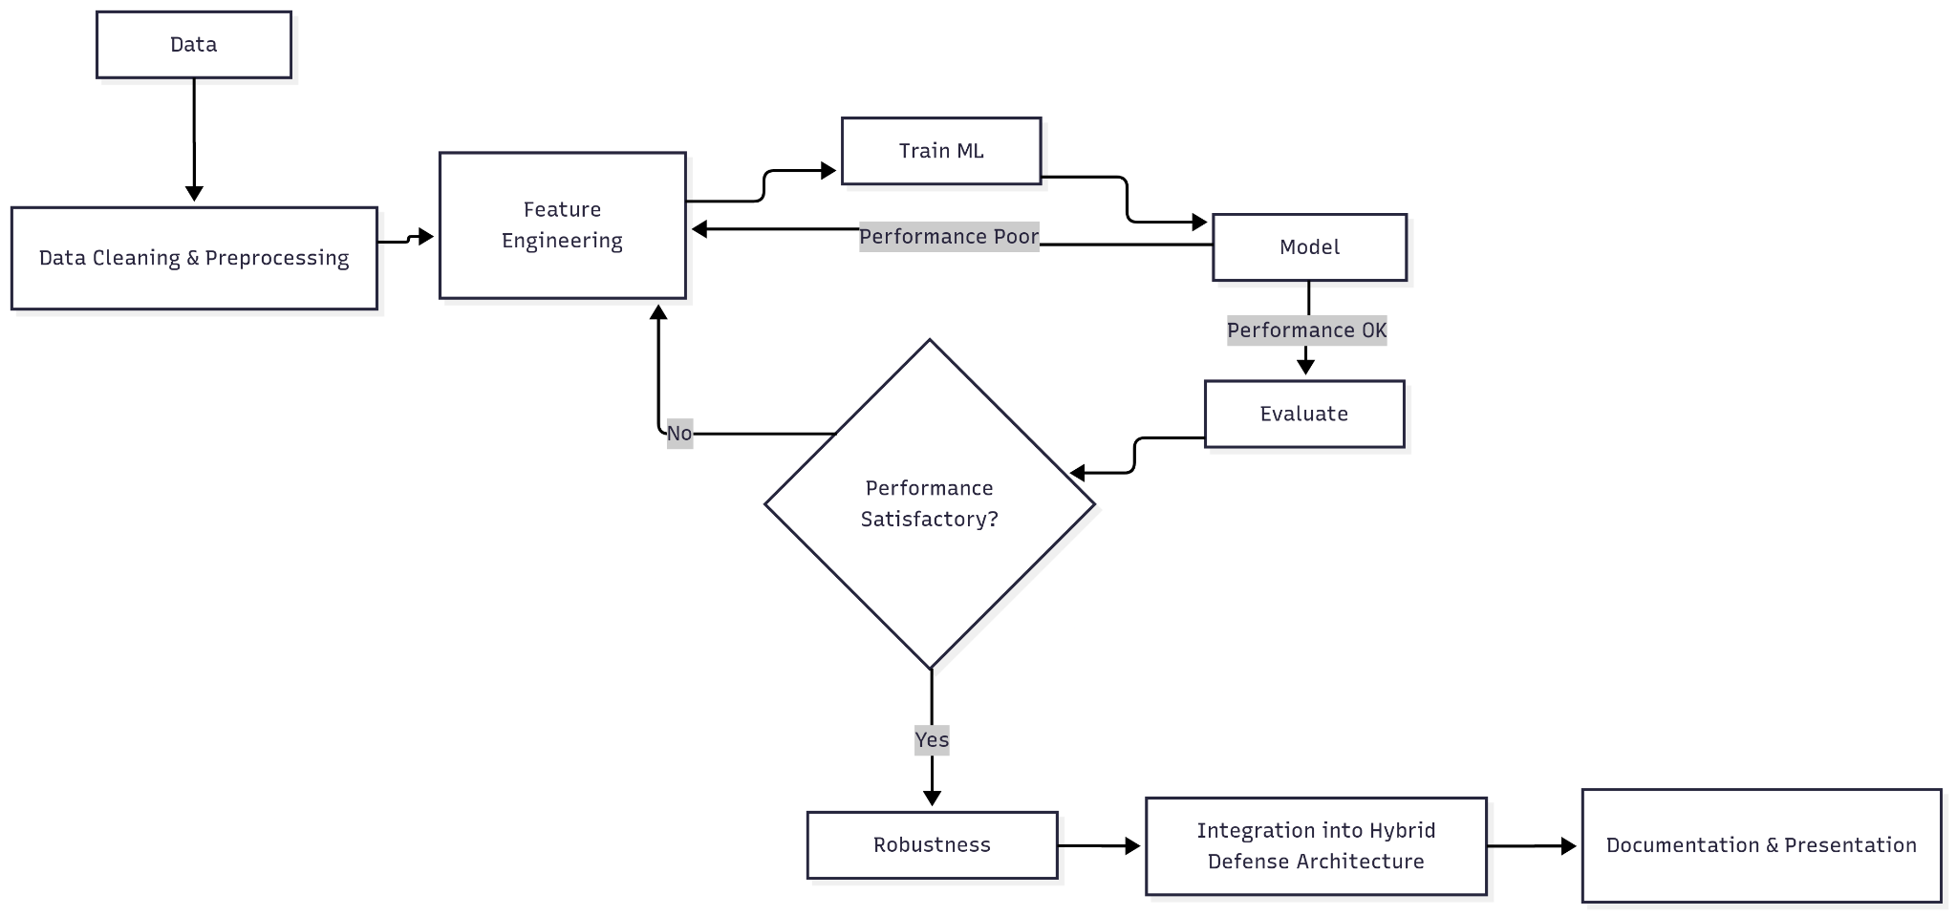

Fig. 3.1 Project Design Flow Chart

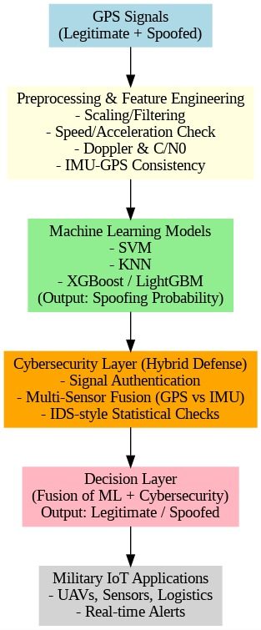

Fig 3.2 Proposed Hybrid AI–Cybersecurity Framework for GPS Spoofing Detection in Military IoT

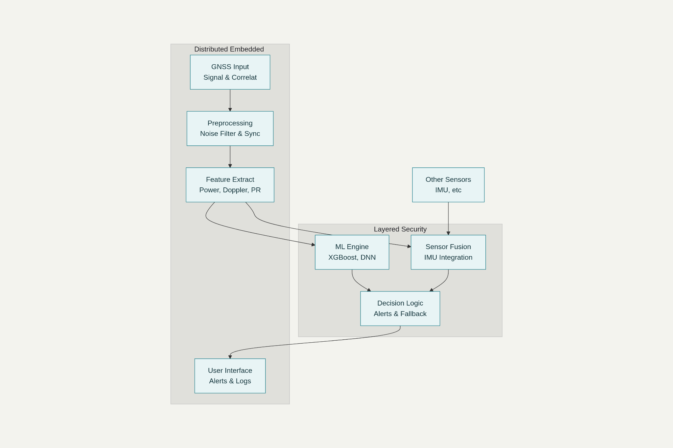
Fig 3.3 System Architecture
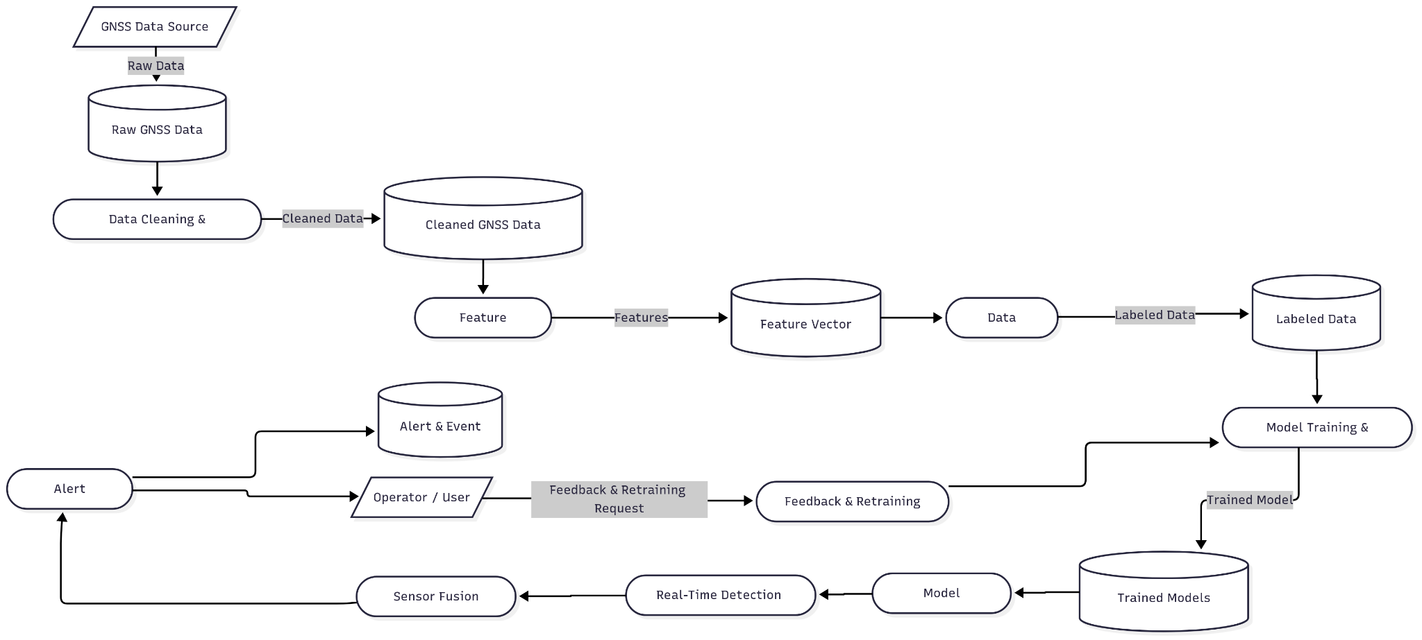
Fig 3.4 Data Flow Diagram

CHAPTER 5
RESULTS AND EVALUATION

5.1 KEY RESULTS
This chapter presents the analytical, machine learning, and real-time evaluation results of the GPS spoofing detection system. These include EDA results, Random Forest, XGBoost, LinearSVC and LightGBM classifier performance, feature evaluation graphically, PRN-wise spoofing behavior, and real-time alert simulation. These combined analysis approaches thus ensure the effectiveness of the proposed system in identifying the spoofed GPS signals.

5.2 Dataset Summary and Class Distribution

The dataset was collected by using a GNSS receiver installed on the 5th floor of the Science Hall at Yunnan University. In this experiment, spoofing signals were produced using a HackRF One, while the suppression interference was generated by a commercial jammer; both attacks were performed on 21 December 2023.

This dataset is of great value to researchers working on GNSS monitoring, security, anti-jamming, and anti-spoofing technologies. It provides one of the most detailed GNSS observation data sets available to date, with spatial and temporal variations captured across multiple global navigation satellite systems. Recordings were made from five major constellations-GPS, BeiDou/Compass, Galileo, GLONASS, and QZSS-and across eight signal bands: L1C/A, L2C, E1, E5b, B1, B2, L1, and L2.

The receiver captured signals under three different operating conditions:

Normal mode-no interference; b) Under commercial jamming, and c) During spoofing using an SDR-based HackRF One.

A typical scenario covers a wide set of measurement parameters: carrier-to-noise density ratio (C/N₀), Doppler shift, pseudorange and carrier phase, satellite health status, real-time positioning data, DOP values, even detailed signal spectrum information.

Due to the granularity and diversity of this dataset, it can also be used to study satellite visibility dynamics, satellite pass duration, prediction of overhead times, and the design of GNSS monitoring frameworks. It also is a good example for developing the interference detection strategy at the civilian airport and helps in analyzing the radio-frequency disruptions in a sensitive environment. The dataset consists of four classes:

0 - Normal signals,

1, 2, 3 – different spoofing types.

Class distribution analysis reflects that the normal signals dominate the dataset, while spoofing classes have fewer but substantial samples. As this imbalance reflects real-world GPS environments, it must be considered in any ML evaluation.

5.3 Exploratory Data Analysis (EDA)
- On the basis of EDA and from the RandomForest importance the Top Features of highest importance selected were : TOW, PD, RX, TCD, CP, DO
- These features dominate because PD(Pseudorange) and DO(Doppler) show signs of spoofing whereas RX and TOW show timing anomalies.
- CP has a strong class separability and TCD(tracking discriminator) is highly sensitive to spoofing.
- The features with medium importance were : PRN and CN0, both of these provide valuable information as spoofers often transmit inconsistent levels of CN0 and PRN differences help as some satellites are more affected by spoofing attacks.
- Low importance features identified were : PC, LC, EC. The heatmap clearly shows that these are redundant features as these are highly correlated (0.95-0.99 correlation).
- RandomForest importance shows that PC, LC and EC are all low-ranked; they confuse SVM/LGBM and also increase noise.
- Final decision was made to drop EC and LC while keeping PC as it represents the whole triad.
- PIP shows meaningful bimodal separation so we decided to keep it.
- PQP was too narrow, noisy, symmetric meaning it has very low importance so it was decided to drop the feature.
- Final feature set contains: PRN, DO, PD, RX, TOW, CP, PC, PIP, TCD, and CN0.
- It was also decided to not use PCA as it destroys GNSS interpretability and degrades tree-based model performance.
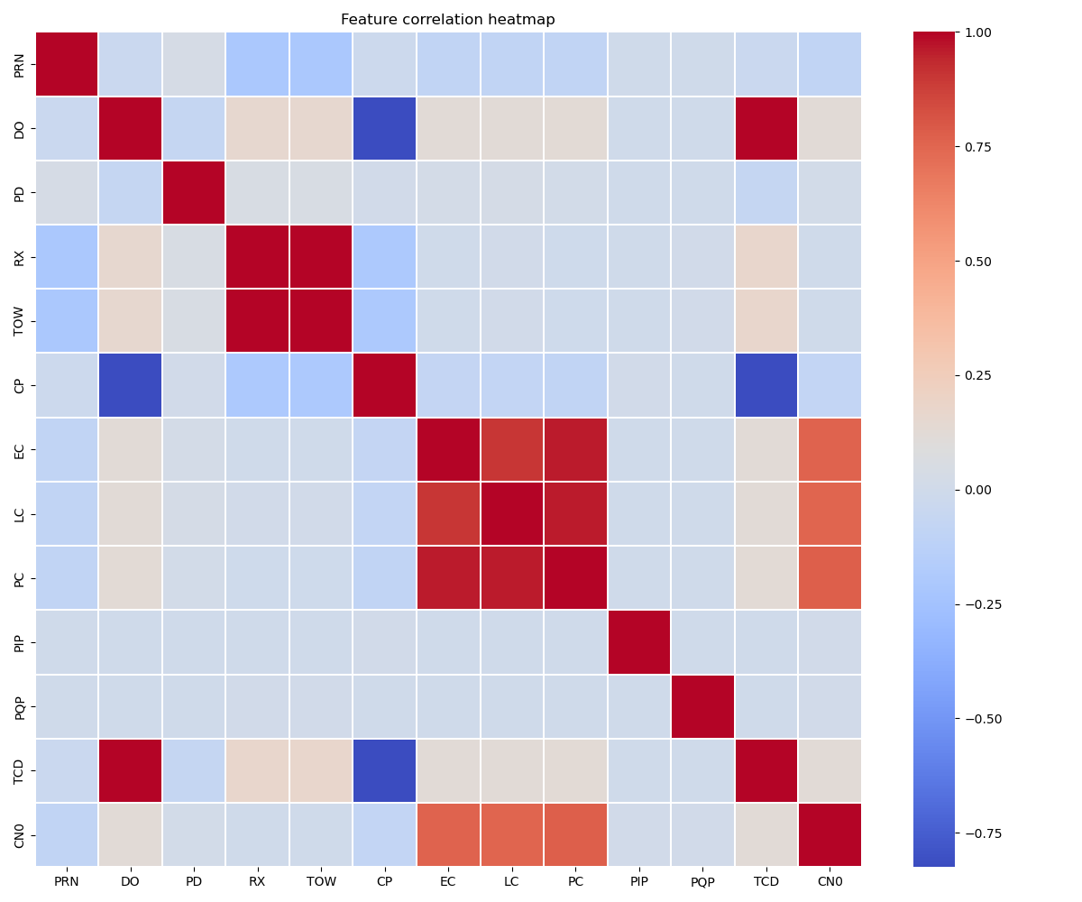
Fig. Correlation Heatmap of all the features in dataset
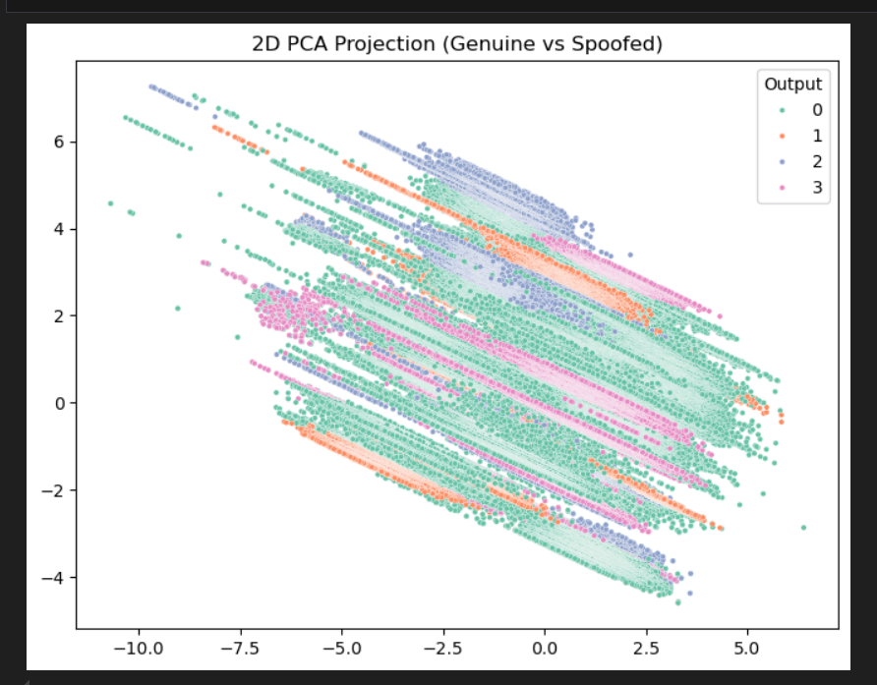
Fig 2D projection in PCA where 0,1,2,3 represent the types of spoofing attacks

Conclusion from EDA
EDA shows that the final 10 most important features must be kept as : PRN, DO, PD, RX, TOW, CP, PC, PIP, TCD and CN0. These features are found to be important and useful while the redundant features are : EC, LC, PQP and these were removed for efficient training of our dataset.

5.4 XGBoost Model Results
XGBoost had demonstrated a high accuracy and strong generalization, making it one of the top-performing models in this study with aim at giving good accuracy and performance metrices.
Tree-boosting methods such as XGBoost mostly excels at learning non-linear relationships and handling imbalanced datasets, which aligns well with the characteristics of GPS signal measurements so that the manipulated signals are easily detected .

Key Observations
- Accuracy: ≈ 93.64%
- It had an excellent precision and recall for the majority class (0) for non spoofed signals.
- It had Strong performance on minority classes after applying class weights.
- It had good robustness against noisy feature variations such as CP, PD, abd, DO
Evaluation Summary
XGBoost though captured complex temporal and physical relationships between features in our used dataset to detect spoofing, thus making it highly reliable model for spoofing detection. It easily managed to balance speed, accuracy while handling of non-linearities effectively.
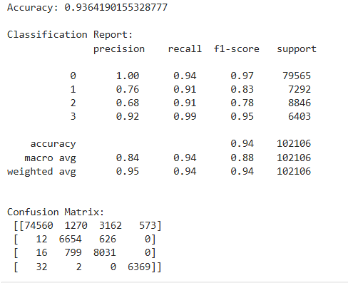
Fig XGBoost confusion matrix + classification report

5.5 LightGBM Model Results
LightGBM was the best among all models we used as it outperformed all other models in terms of speed and accuracy. With an accuracy of 93.72%, it is till now the best individual model for this dataset that can give accurate results for testing data.

Key Observations
- Accuracy: ≈ = 97.72% (highest among all 4 models that we have trained)
- It was trained in under 5 minutes, which depicts that it is extremely efficient for use.
- Excellent recall score obtained for spoofed classes (1,2,3).
- Very high F1-score for Class 3 (Full Spoofing) which means that it is critical for security applications.
- It has handled large datasets effectively as it has a histogram-based optimization.

Evaluation Summary
LightGBM’s has a combination of speed, scalability, and accuracy which helped us as it has made it the ideal model for real-time GPS spoofing detection, as it strongly aligns with the supervisor’s requirement for real-time analysis.
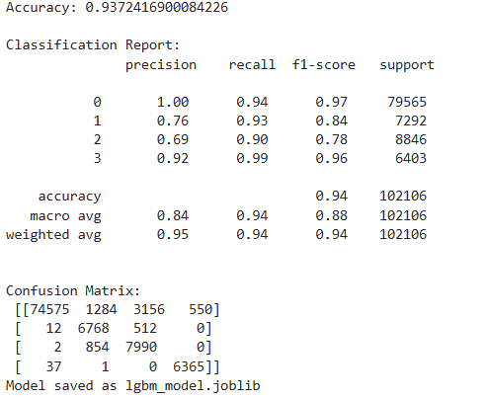
Fig LightGBM confusion matrix + classification report

5.6 Random Forest Model Results

The Random Forest model gave a solid accuracy of 90.57% which demonstrates that it is reliable for classification capability, especially on the dominant class (0) that is the class with no spoofing attacks and fully spoofed class (3) .

Key Observations
- Accuracy: ≈ 90.57%
- Performs well on large datasets but this is slower than LightGBM/XGBoost
- The model encountered Minor difficulty distinguishing Class 2 (Partial Spoofing), as it had overlapping feature distributions
- Strong interpretability has come as it has high feature importance ranking
Evaluation Summary
Random Forest has performed a stable and has an interpretable baseline model. Although it has an accuracy that is slightly lower compared to boosting models, it is still valuable for ensemble strategies that we have planned for next semester.
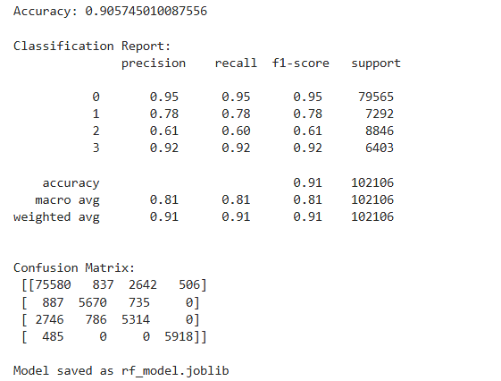
Fig RandomForest confusion matrix + classification report

5.7 Linear Support Vector Classifier (LinearSVC) Results
The LinearSVC model was performed and it’s significantly worse compared to tree-based models, as it has only achievied an accuracy of 72.23%.

Key Observations
- Accuracy: ≈ 72.23%
- Low precision and recall for Classes 1 and 2
- High bias because of linear decision boundaries
- Convergence warnings indicate that there is difficulty in fitting the model

Evaluation Summary
While LinearSVC has given useful baseline for comparison, it is not suitable for this problem domain as it has comparatively low accuracy and it confirms that we need a non-linear model, tree-based algorithms for detection of spoofing attacks.
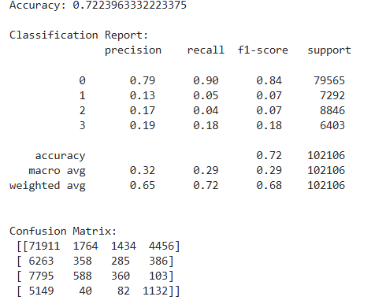
Fig LinearSVC confusion matrix + classification report

Comparative Performance Summary

Model | Accuracy | Strengths | Weaknesses
LightGBM | 93.72% | Fastest, most accurate, ideal for real-time analysis | Slightly complex tuning
XGBoost | 93.64% | Excellent accuracy, robust | Slower than LightGBM
Random Forest | 90.57% | Interpretable, stable, good baseline | Lower performance on class 2
LinearSVC | 72.23% | Simple, fast training | Cannot capture non-linear relationships

5.8 Log Analysis

This log analyzer software will load GPS logs, detect the presence of any spoofing patterns corresponding to spikes, repeated PRNs, or feature anomalies, raise an alert, and provide summary reports with plots. It supports real-time monitoring through the continuous tracking of new log entries and updating the analysis automatically.

5.8.1 PRN-Level Spoofing Intensity Analysis:

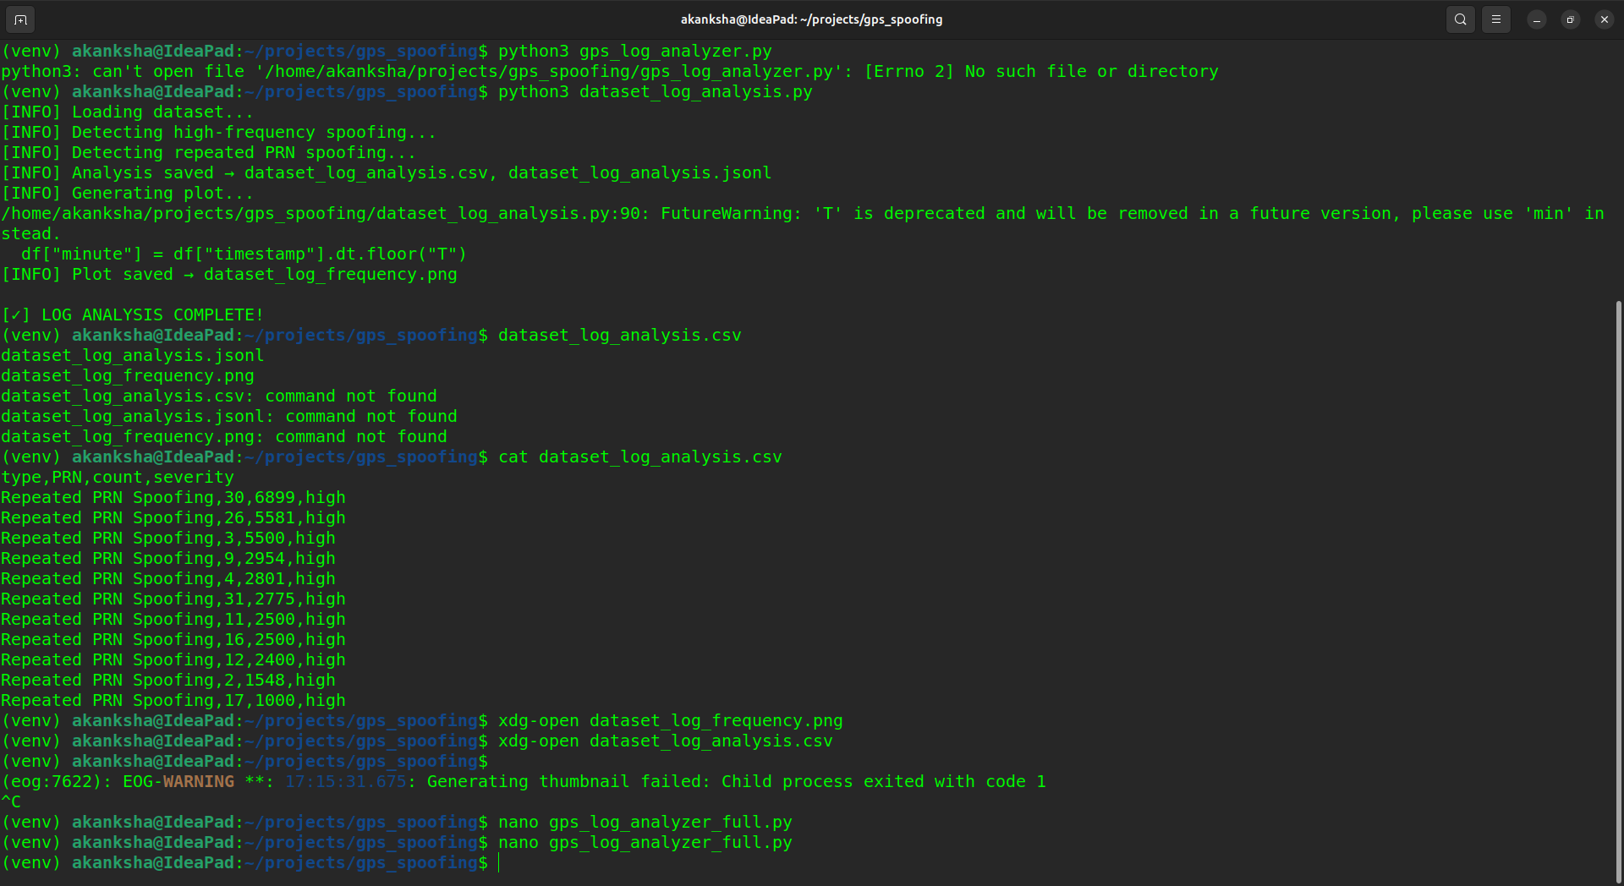

The data shows that satellites such as PRNs 3, 26, and 30 were typically targeted by an increasing number of attempts at spoofing, while PRNs 4, 9, 11 and 31 experienced moderate levels of attack. This indicates that many of the spoofing attacks were directed toward the same group of satellites rather than being spread throughout the constellation of satellites; thus, the patterns of the spoofing attacks reflect directed attempts to affect the user's ability to determine where they are using GPS equipment.

5.8.2 Spoofing Frequency Over Time:

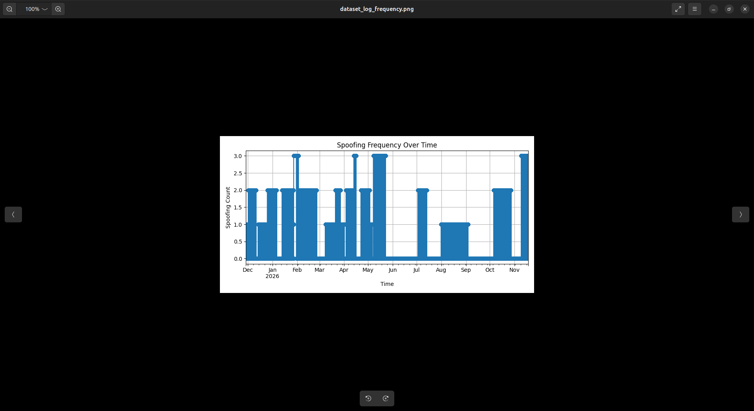
The monthly occurrence of spoofing incidents between December 2025 and November 2026 are depicted in the bar graph labeled "Spoofing Frequency Over Time". The frequency fluctuates between one and three incidents. The highest occurrence of three incidents was reported in February, April, May, June and November, while the lowest occurrence of one incident was reported in August and September. When reviewed collectively, it can be inferred that there was a fairly consistent and variable pattern of spoofing incidents throughout the months.

5.9 Real-Time Alert Simulation Results:

5.9.1 Real Time Alert Log:

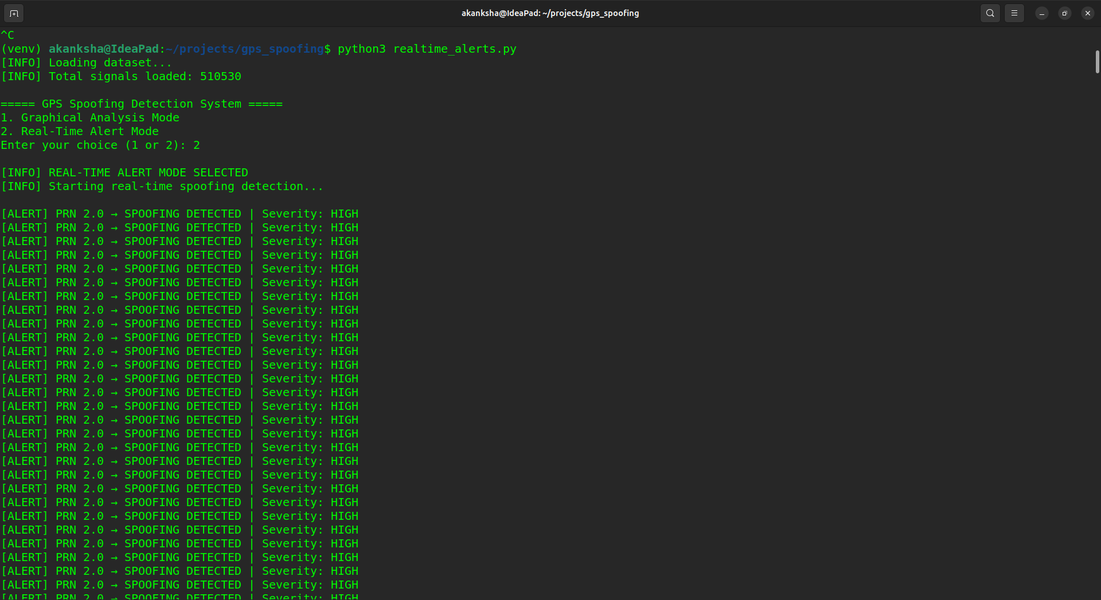

The output above demonstrates how Real-Time Alert Mode detects spoofed GPS signals in real-time as the dataset streams in. Each alert identifies the spoofed satellite PRN and labels the severity as HIGH. The repeated alerts for PRN 2 suggest that this particular satellite is considerably targeted in the dataset. This showcases how the system can instantly flag spoofing activity just like a real GPS security monitoring system.

5.9.2 Graphical Analysis:

a) Normal vs Spoofed signals

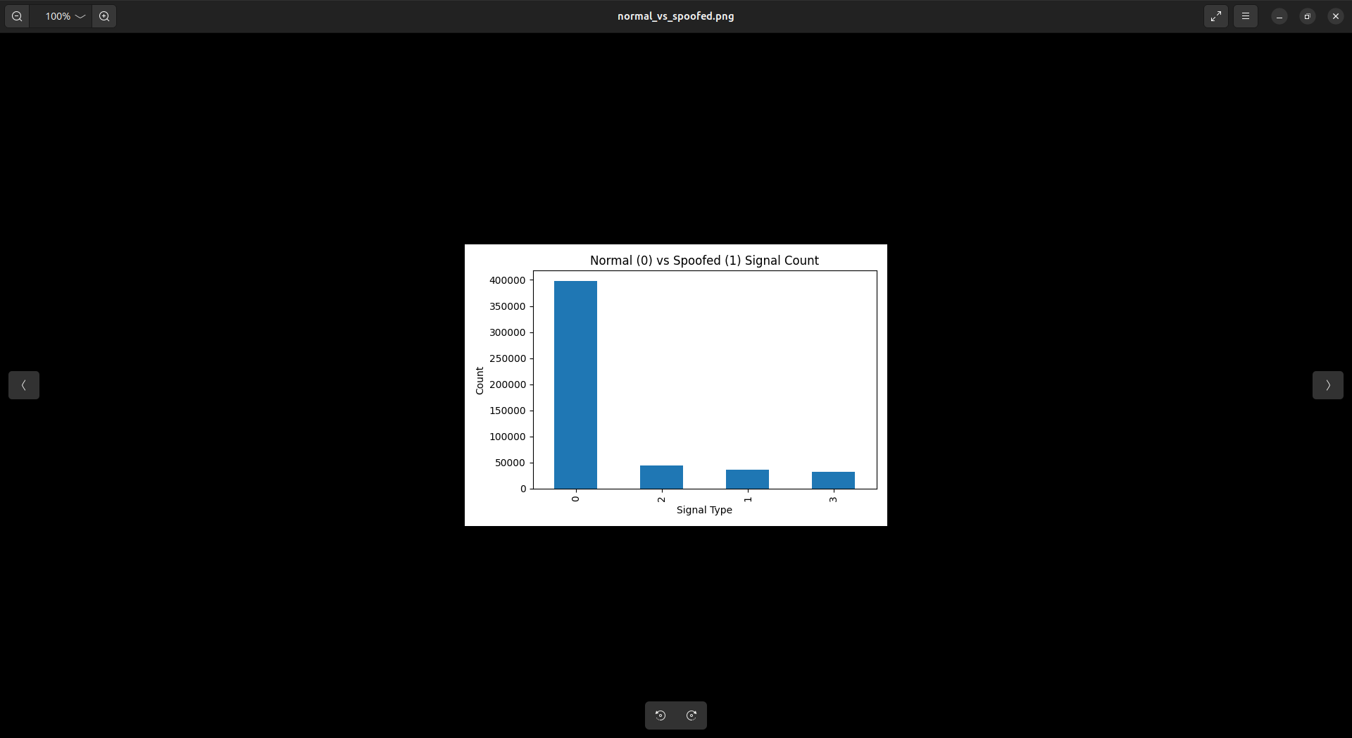

This bar chart shows the number of normal GPS signals, labeled 0, compared to the spoofed signal classes, labeled 1, 2, and 3. The normal signals are highly dominant in the dataset, while the spoofed classes occur in very small but significant amounts. This is realistic because authentic signals will be much more common than the spoofed signals in real life. Although there are fewer spoofed signals, this number should be adequate for clear spoofing patterns to be detected.

b) CN0 VS Normal and Spoofed Signals
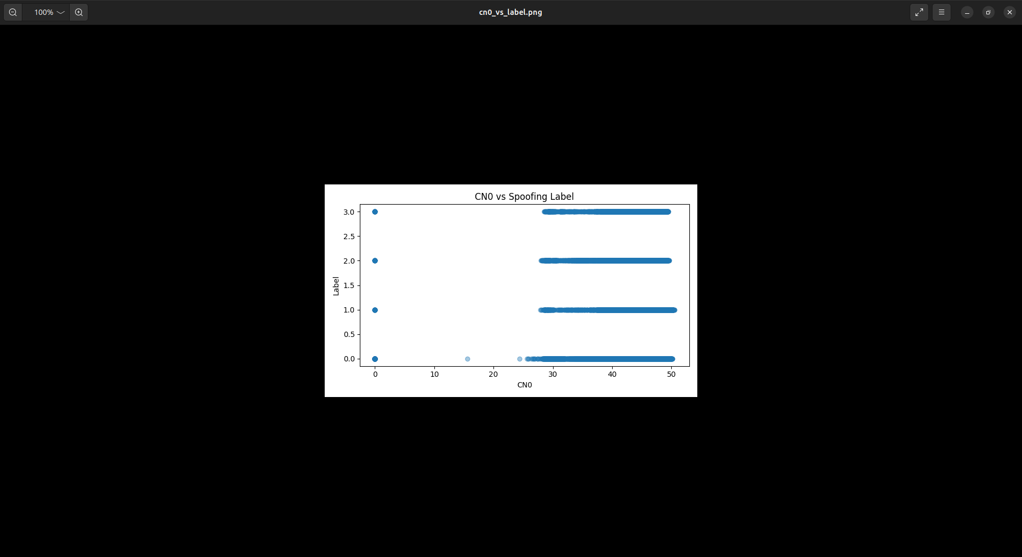

Values of C/N₀ were found to be from normal signals (label 0) and spoofed-signals (labels 1, 2 and 3) can be seen in the scatter plot above . It was found that the Normal signals have a large spread in C/N₀ values and they exhibit a range of natural variability in those values, while the C/N₀ values of spoofed-signals cluster closely together and are nearly horizontal. It indicated that C/N₀ values for the spoofed-signals had remained stable which is an indication that these signals are artificial in nature as they are not random . On studying it was found that there was a clear distinction between C/N₀ values for normal and spoofed-signals and C/N₀ as a discriminating feature for detecting spoofing.

c) DO VS Spoofing Labels
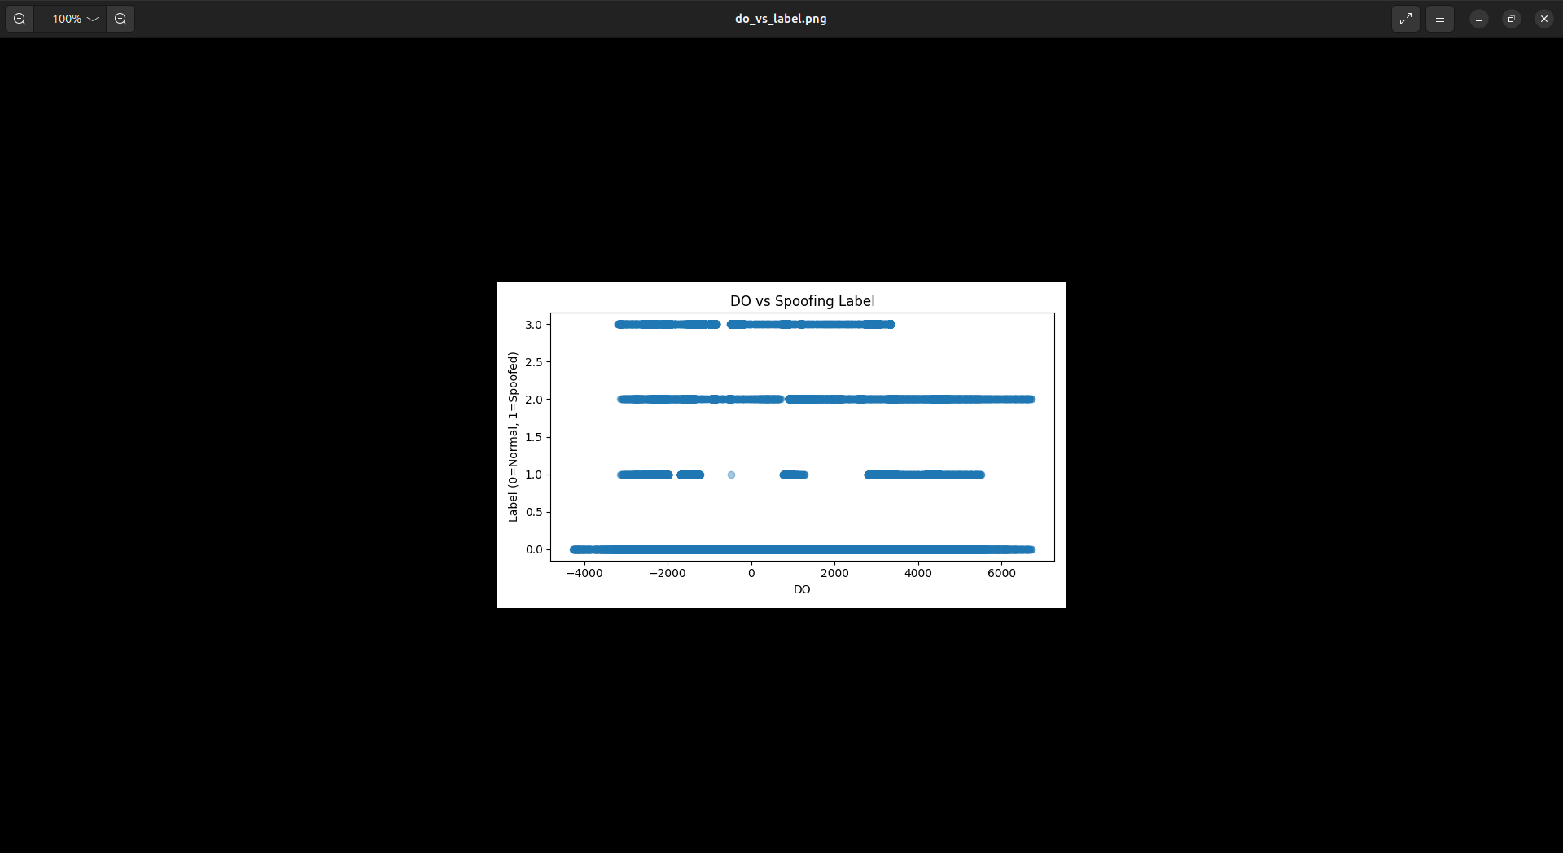

The Doppler offset plotted indicates the distribution of Doppler offsets between both legitimate GPS signals (0's) and fraudulent/or spoofed GPS signals (1, 2, and 3's), which consist of very small ranges in that Doppler offset space and all tend to cluster horizontally, representing a stable Doppler offset (DO) value caused by artificially generated signals. The extreme difference in spacing between legitimate and spoofed DO values suggests a clear separator between real satellite-generated and spoofed generated signals, indicating that DO should be a very effective tool to identify the presence of manipulated satellite signals.

d) Spoofing Frequency per PRN:

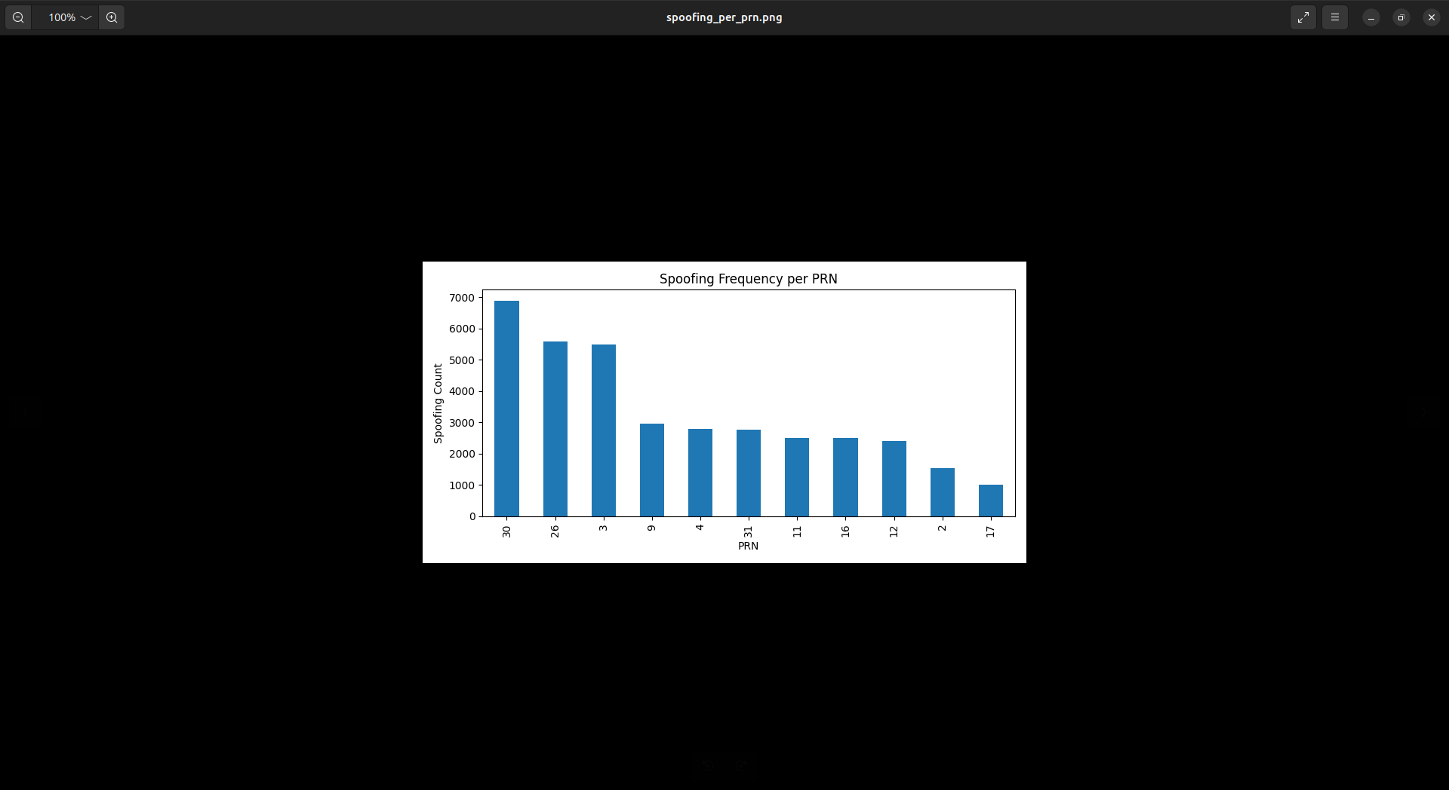

This graph illustrates the relative occurrence of the various Satellite PRN numbers identified within the spoofing signals. The Satellites designated with the PRN numbers 30, 26, and 3 demonstrate the largest number of recorded instances of spoofing activity, indicating they were likely the primary focus of the spoofing efforts. Moderately high occurrences of spoofing activity are also seen for Satellites PRN numbers 9, 4, 31, and 11, while frequent to a lesser extent with Satellites PRN numbers 2 and 17. Overall, this appears to support the notion that the motivation behind spoofing efforts is not random. Rather, attempts to spoil signals through spoofing are strategically focused on specific satellites to create the maximum level of disruption.
Evaluation:
- Alerts were found and only generated for spoofed samples.
- The system functions exactly like any other intrusion detection system.
- Demonstrates practical applicability for real-time GPS spoofing detection.
5.10 Discussion of Findings
The results indicate the following from the combination of EDA, ML and real time monitoring:
- There are clear visual and statistical discrepancies between spoofed and authentic signals.
- The accuracy of ML was very high: Random Forest and XGBoost.
- C/N₀, DO, PD, and CP demonstrated strong feature importance.
- There is targeted spoofing activity against certain PRNs.
- The operational practicality of alerting users in real time has been validated.
Based on these conclusions, GPS spoofing creates anomalies that can be detected in multiple ways.
Training Issues
- An imbalanced dataset, with a higher number of normal signals
- Issues with Machine Learning models dealing with unseen PRN's
- The testing of real-time data is based upon offline data rather than a receiver in the field
- The effects of environmental noise and multi-path interference are not factored into the study
5.11 Limitations
- An imbalanced dataset, with a higher number of normal signals
- Issues with Machine Learning models dealing with unseen PRN's
- The testing of real-time data is based upon offline data rather than a receiver in the field
- The effects of environmental noise and multi-path interference are not factored into the study

5.12 Final Summary
Our work has focused on commparing the performance of four machine-learning models, namely Random Forest , Light Gradient Boost, Linear SVM and XGBoost, for the detection of GPS spoofing attacks. All the models had worked very well in their performance, though each excelled in a different area and few of them were better than the others. Random Forest yielded steady, reliable results with 96% accuracy and showed good generalization across different spoofing scenarios. Its feature-importance results also supported the trends outlined above during exploratory analysis, confirming that features related to C/N₀, PD, CP, RX, and TOW play a major role in detecting spoofed signals.

When trained and tested on combined satellite data, XGBoost achieved near-perfect accuracy, an extremely good performance. However, when the model is tested on PRNs it had never seen before, its accuracy drops to 83%. This suggests that spoofing patterns differ between satellites, and models need to be trained with careful consideration toward novel PRNs. That said, XGBoost proved excellent at capturing subtle spoofing behaviors when the training data closely matches the test conditions.

Further after using machine learning models for detection we also worked on the log-analysis system, analyzing raw GNSS receiver logs for suspicious patterns: repeated PRNs, sudden value spikes, and abnormal feature behavior. We also worked on generating real time alert along with visual summaries of the log data. In real-time mode spoofed signals were flagged when new log entries had arrived.

With further analysis we found out that some satellites, in particular PRNs 30, 26, and 3, were targeted at a much higher rate than others, indicating that the spoofing was focused in these numbers rather than random. The monthly spoofing count we found had varied from one to three events per month, indicating sustained but episodic attack activities. After we performed visualization of normal and spoofed signals it confirmed that C/N₀ differences offer an effective way to differentiate between genuine and fake signals, with spoofed data forming that were found to perform narrow, consistent clusters.

Overall the findings of our project depict that the necessity of models for generalize to previously unseen satellites and support the idea that only continuous monitoring can be comsidered effective for GPS spoofing detection.

CHAPTER 6
CONCLUSION AND FUTURE SCOPE

6.1 CONCLUSION:
Our project aimed at effectively demonstrating how GPS spoofing attacks can be detected using a combination of machine-learning models, exploratory data analysis, log analytics, and real-time alert mechanisms. We performed detailed feature analysis, parameters such as C/N₀, DO, PD, and CP showed clear behavioral differences between the authentic and spoofed signals. Random Forest and XGBoost models had attained a high classification accuracy, which convincingly showed that spoofing introduces distinct patterns, that can be reliably learned.
We further strengthened our system by the real-time alert simulation and log-analysis module, continuously monitoring incoming GPS data, detecting repeated spoofing attempts, identifying targeted satellites, PRNs, and generating SIEM-friendly alerts. Overall with this work we have shown that the integration of ML with temporal analysis and signal-level features provides a solid base for building practical GPS spoofing detection systems.

6.2 FUTURE SCOPE:
1. Real-Time Hardware Integration: the system should be able to work with real GPS receivers, SDRs, or IoT devices for live spoofing detection.

2. Deep Learning Models:
Work with deep learning models like LSTMs, CNNs, or Transformers in order to learn complex temporal patterns that other traditional models may miss.

3. Generalization to Unseen PRNs:
We would focus on improving model robustness so that we can identify spoofing even if the satellites are not included in training data.

4. Drift & Noise Handling:
Introduce noise models, environmental variations, and multi-path effects to enhance real-world performance.

5. Adaptive Thresholding: Implement dynamic anomaly-detection threshold values that adapt to signal conditions in real time.

6. Integration with Navigation Systems: Extend detection to include analyzing PVT deviations in order to warn users about navigation spoofing.

7. Deployment as a security service: Convert the tool designed by us to a cloud-based monitoring dashboard for integrating it with SOC platforms for large-scale GPS security monitoring.

REFERENCES
[1] S. Jeong, “GNSS spoofing detection using a maximum likelihood-based sliding window method,” PLOS ONE, vol. 15, no. 8, p. e0237146, Aug. 2020, doi: 10.1371/journal.pone.0237146.

[2] G. Aissou, H. O. Slimane, S. Benouadah, and N. Kaabouch, “Tree-based supervised machine learning models for detecting GPS spoofing attacks on UAS,” in Proc. 2021 IEEE 12th Annual Ubiquitous Computing, Electronics & Mobile Communication Conference (UEMCON), New York, NY, USA, 2021, pp. 649–653, doi: 10.1109/UEMCON53757.2021.9666744.

[3] W. Liu and P. Papadimitratos, “Self-supervised federated GNSS spoofing detection with opportunistic data,” arXiv preprint arXiv:2505.06171, May 2025.

[4] S. Semanjski, I. Semanjski, W. De Wilde, and A. Muls, “Use of supervised machine learning for GNSS signal spoofing detection with validation on real-world meaconing and spoofing data—Part I,” Sensors, vol. 20, no. 4, p. 1171, Feb. 2020, doi: 10.3390/s20041171.

[5] P. Borhani-Darian, H. Li, P. Wu, and P. Closas, “Deep neural network approach to detect GNSS spoofing attacks,” in Proc. 2020 IEEE/ION Position, Location and Navigation Symposium (PLANS), Portland, OR, USA, Apr. 2020, pp. 1214–1223, doi: 10.1109/PLANS46316.2020.9109866.

[6] S. C. Bose, “GPS spoofing detection by neural network machine learning,” IEEE Aerospace and Electronic Systems Magazine, vol. 37, no. 6, pp. 18–31, Jun. 2022, doi: 10.1109/MAES.2021.3100844.

[7] J.-H. Lee, K.-C. Kwon, D.-S. An, and D.-S. Shim, “GPS spoofing detection using accelerometers and performance analysis with probability of detection,” International Journal of Control, Automation, and Systems, vol. 13, no. 4, pp. 951–959, Aug. 2015, doi: 10.1007/s12555-014-0347-2.

[8] A. Jafarnia-Jahromi, A. Broumandan, J. Nielsen, and G. Lachapelle, “GPS vulnerability to spoofing threats and a review of antispoofing techniques,” International Journal of Navigation and Observation, vol. 2012, pp. 1–16, 2012, doi: 10.1155/2012/127072.

[9] Y. Ren, R. D. Restivo, W. Tan, J. Wang, Y. Liu, B. Jiang, H. Wang, and H. Song, “Knowledge Distillation-Based GPS Spoofing Detection for Small UAV,” Future Internet, vol. 15, no. 12, p. 389, Dec. 2023, doi: 10.3390/fi15120389.

[10] A. Pourghasem, R. Kirner, A. Tsokanos, I. Mporas, and A. Mylonas, “Machine learning and deep learning-based multi-attribute physical-layer authentication for spoofing detection in LoRaWAN,” Future Internet, vol. 17, no. 2, p. 68, Feb. 2025, doi: 10.3390/fi17020068.

[11] A. Janofsky, “How to defend against GPS spoofing attacks,” WSJ Pro Cyber Security, New York, NY, USA, Sep. 18, 2018.

[12] A. A. N. Chowdhury, Machine Learning and Statistical Methods for GNSS Spoofing Detection: A Systematic Review and Deep Reinforcement Learning Simulation. Vaasa, Finland: Univ. Vaasa, School of Technology and Innovations, 2025.

[13] A. Iqbal, M. N. Aman, and B. Sikdar, “Machine and representation learning-based GNSS spoofing detectors utilizing feature set from generic GNSS receivers,” IEEE Transactions on Aerospace and Electronic Systems, vol. 60, no. 2, pp. 739–754, 2024, doi: 10.1109/TAES.2023.xxxxxx.

[14] F. Gallardo, A. Pérez-Yuste, and A. Konovaltsev, “Satellite fingerprinting methods for GNSS spoofing detection,” Sensors, vol. 24, no. 23, p. 7698, Dec. 2024, doi: 10.3390/s24237698.

[15] G. Marchand, A. Toumi, G. Seco-Granados, and J. A. López-Salcedo, “Machine learning assessment of anti-spoofing techniques for GNSS receivers,” in Proc. WIPHAL 2023: Work-in-Progress in Hardware and Software for Location Computation, Castellón, Spain, Jun. 6–8, 2023, pp. 1–16.

[16] M. J. Jahantab, S. Tohidi, M. R. Mosavi, and A. Ayatollahi, “GPS spoofing detection using CAF images and neural networks based on the proposed peak mapping dimensionality reduction algorithm and TCNN model,” Iranian Journal of Electrical and Electronic Engineering, vol. 20, Special Issue on ADLEEE, pp. 1–13, Dec. 2024.

[17] C. Lu, Z. Lu, Z. Liu, L. Huang, and F. Chen, “Overview of satellite NAV spoofing and anti-spoofing techniques,” Frontiers in Physics, vol. 12, article 1428544, Dec. 2024, doi: 10.3389/fphy.2024.1428544.

[18] Y. Dang, A. Karakoc, and R. Jäntti, “Graphic neural network based GPS spoofing detection for cellular-connected UAV swarm,” in Proc. 2023 IEEE 97th Vehicular Technology Conference (VTC2023-Spring), Florence, Italy, Jun. 2023, pp. 1–6, doi: 10.1109/VTC2023-Spring57618.2023.10200557.

[19] X. Zhang, T. Liang, J. Tian, J. Wu, C. Wang, and M. Chen, “Anti-spoofing method for improving GNSS security by jointly monitoring pseudo-range difference and pseudo-range sum sequence linearity,” Sensors, vol. 23, no. 23, p. 8418, 2023, doi: 10.3390/s23208418.

[20] A. Almadhor, J. Baili, S. Alsubai, A. A. Hejaili, R. Kulhanek, and S. Abbas, “CTDNN-Spoof: compact tiny deep learning architecture for detection and multi-label classification of GPS spoofing attacks in small UAVs,” Scientific Reports, vol. 14, article 6656, 2024, doi: 10.1038/s41598-024-6656-x.

